Edureka

Blockchain Certification Tranining

Certification Project

Mariano Gadea

Within the zip file you can find:
- property.js file
- property.sol file
- PropertyManagement.html file
- This document

Files can be also found in: https://github.com/marianogadea/Ethereum

Also the following information is needed to run and test the contract:

Contract address (Ropsten network): 0x99452a12cbfd29d07a633e5172bc27eefa9d14e9

Government address: 0x7a949c4eb3d9b83849c1e9b15d97a0a23999a50a
Government private key (if you want to create new properties): 5c7861c7bf2231d836207dd41134f0c070dfbc60f03410d09772a5c13de116cd

Address User 1: 0x97b69c1c6f512a588d0d6df0023d67996926cc45
Private key User 1: 4973540615698c0bec1cfeb77f863a2bbe6078b4cabb461223dd3b8b1bf1e7f4

Address User 2: 0x6138439fa3d19bddad4c5e15f34f400c992d9aa9
Private key User 2: 68bae2a1e0b695ac04914a99f2f2a4a59e10eae9ab04f57da6bf72ac8e9e2b4d

Address User 3: 0xd651d3011e9f1f4b5ff1c69aef178b96d65e78fe
Private key User 3: 25ea24e8c0e460001a901e84d7e51dbdf8c87d9f7c6654f85adffdb8674f191a

First I publish the contract in Ropsten Network:

Then I ask some Ethers for contract owner:

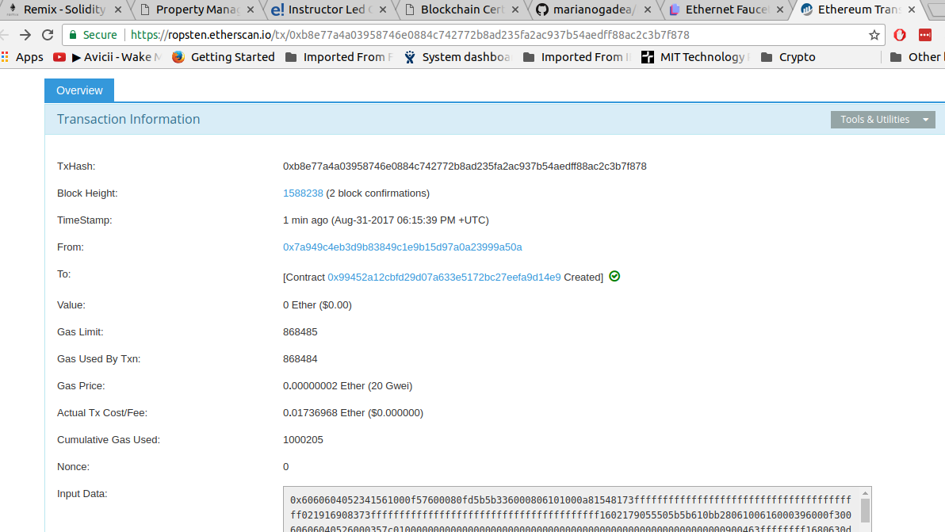
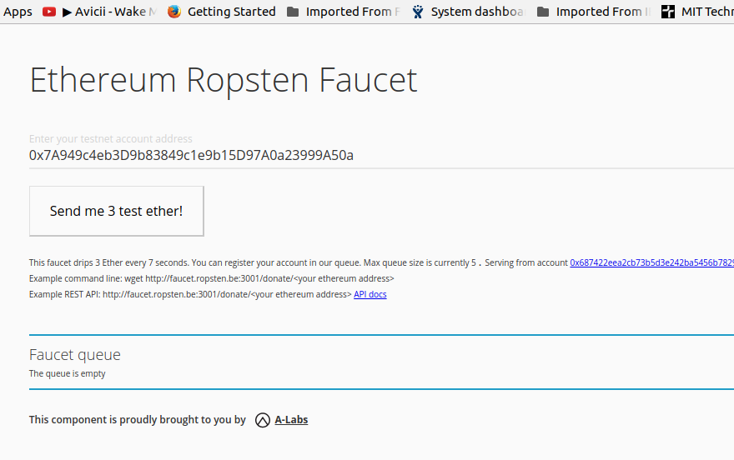
I create the contact in remix and this is the result:
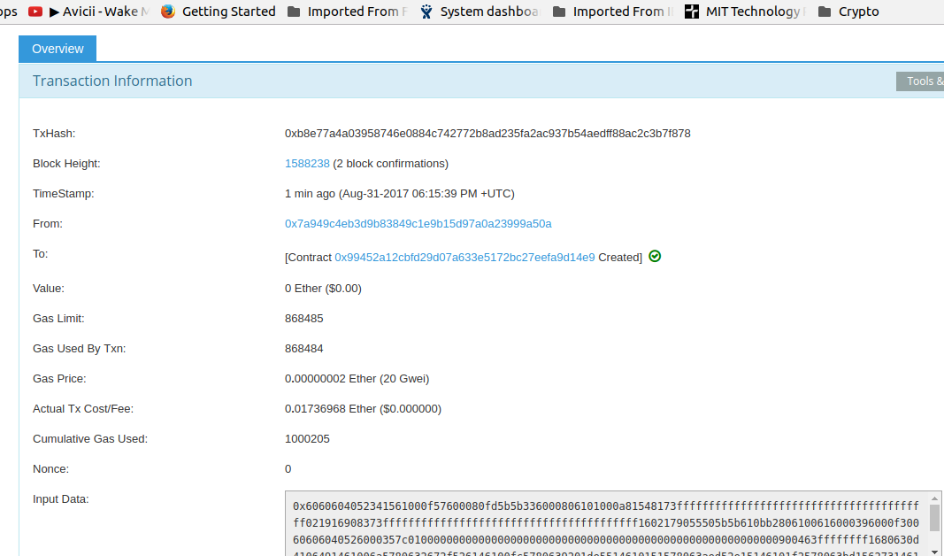
I’ve changed the html code with new abi and contract address taken from remix:
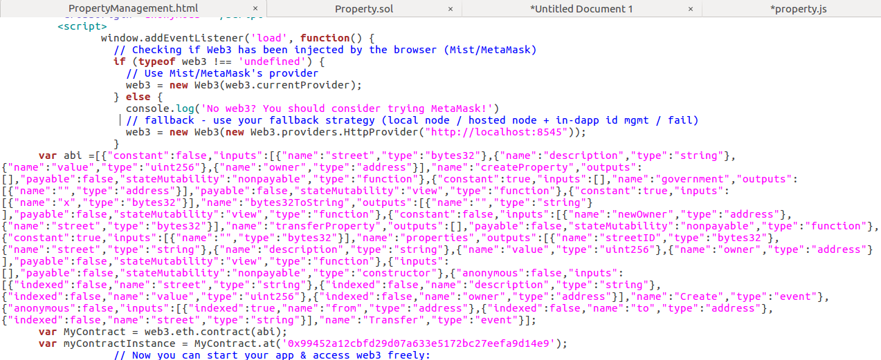
Then I start http server in my PC:
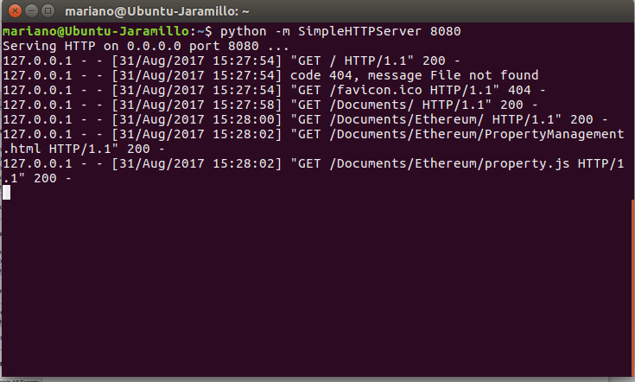

Then I open the hml file from my browser:
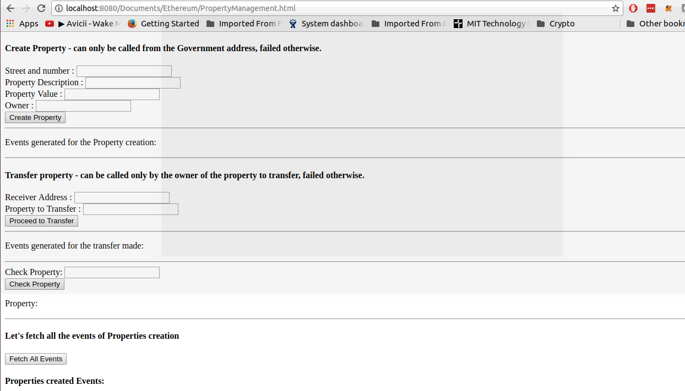
Now I will send some coins to User 1, User 2 and User 3 using Metamask and from Primary account in order to have some gas.

I will create 5 properties, 2 will be assigned to User_1, 2 will be assigned to User_2 and 1 will be assigned to the Government (Contract creator):
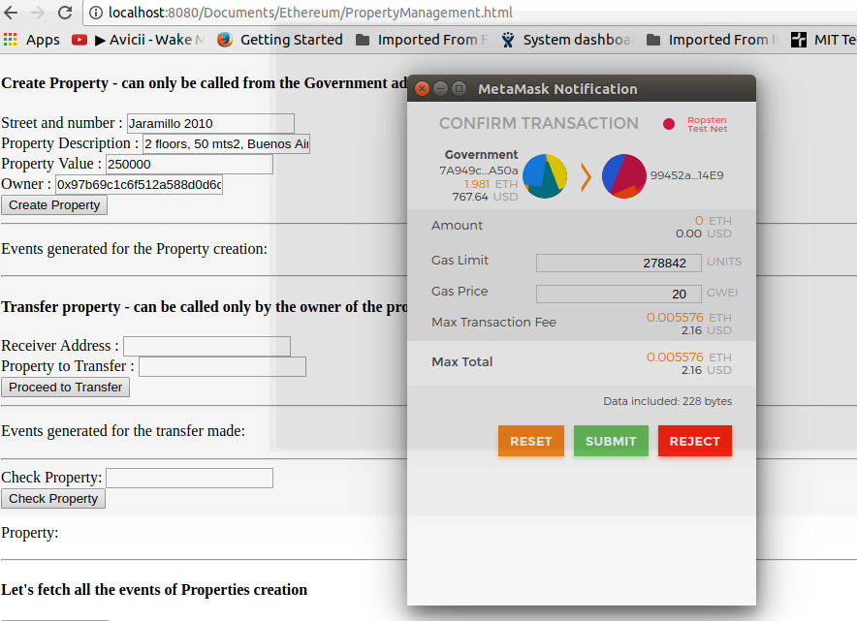
Property creation has been mined after some seconds:
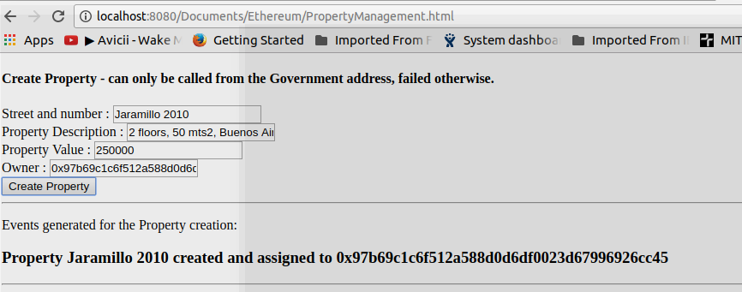
I can check property:
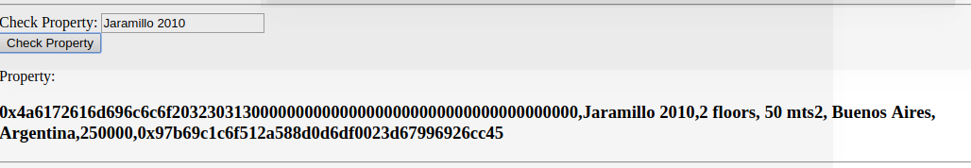
Now I will transfer the property “Jaramillo 2010” to User_3 (address “0xd651d3011e9f1f4b5ff1c69aef178b96d65e78fe”) using User_1 metamask account (“0x97b69c1c6f512a588d0d6df0023d67996926cc45” address) :

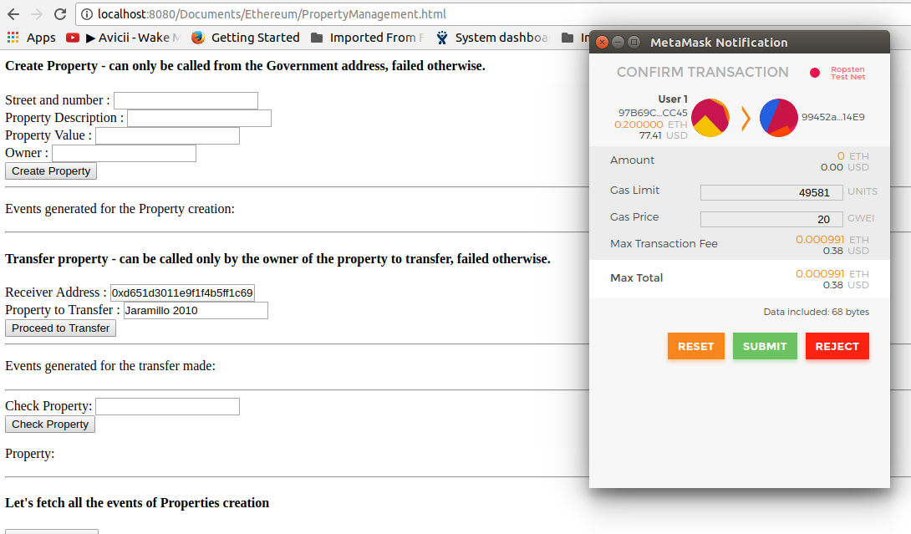

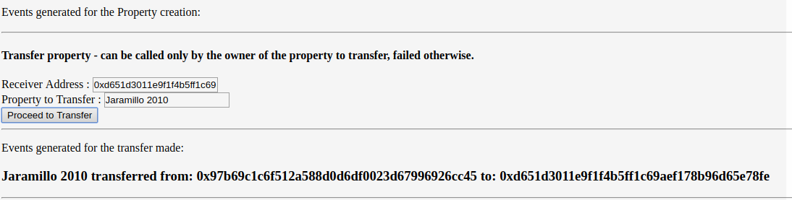

If I want to transfer an property that is not owned by the sender this is what happen and the property remains with the original owner:

